**Phase 58:-**

Now suppose we create an audience in which there are people who saves the post and then there is an audience which message in our Instagram

We can make two ad group on basis of them and exclude them from each other (because there audience may coincide as some people may be saving the post and sending meassage as well who knows

So try to understand different different option and what id there meaning   
How to use these option so that we can reach a better audience as we know when we have custom audience then we can create a lookalike audience

**Lesson 46:-**

In this lesson we will learn about **Basis of events in Facebook page**

We will see how t create an event based audience so guys we need to understand that wht does it mean by events

When we are in our Facebook page then we get option there that we can create different option here.

Lets say we are doing an offline or maybe online seminar in our page then we can create it as an event and then we can promote this event and many people will give response on this event

By response we mean people who are interested in going to that event they will click on interest button or people who will definitely come will click on going button

So by this type the event we create whether online or offline then we can promote it and many people will interact with it So by there interaction on it we can create a custom audience

**Note:-**

Here event means different from what recently we have studied

So we try to understand where we see the option of events that the teacher is talking about

Now we will go to manage page section of our page

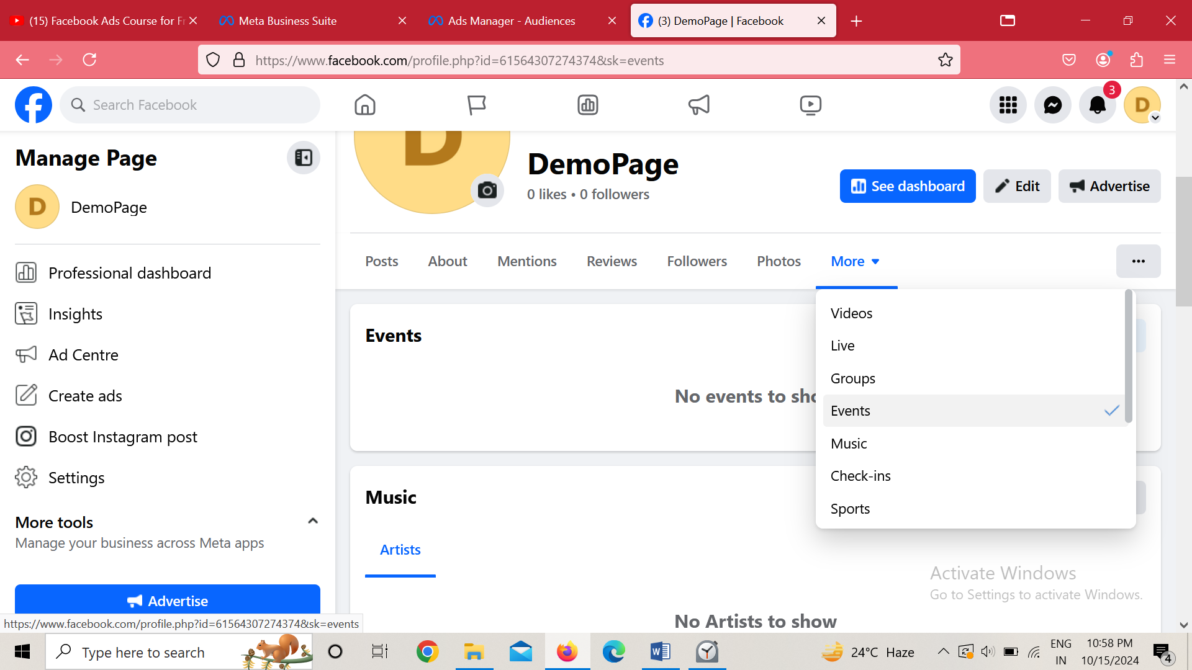

And then click on more a submenu will be shown below

Now click on Events

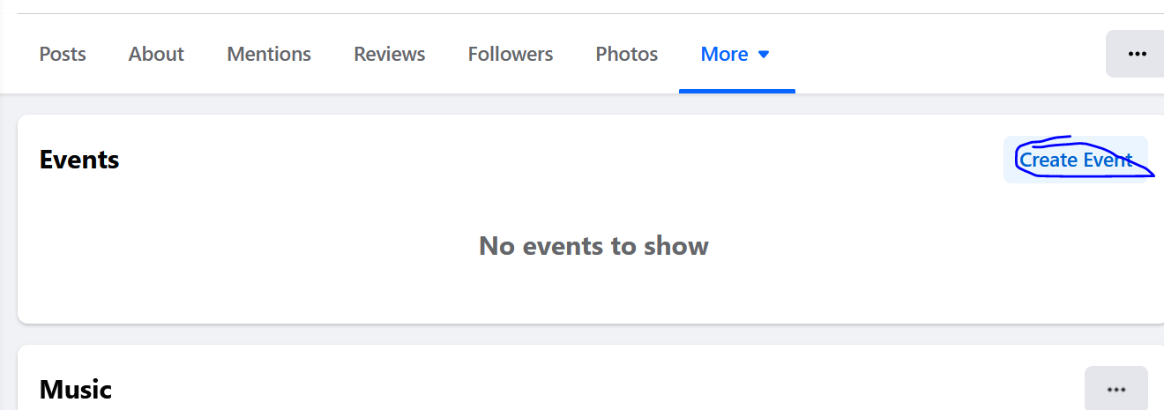

Now page will look like above abd then click on Create event button

Teacher is from different era so event createino step is different from him

So we will see his

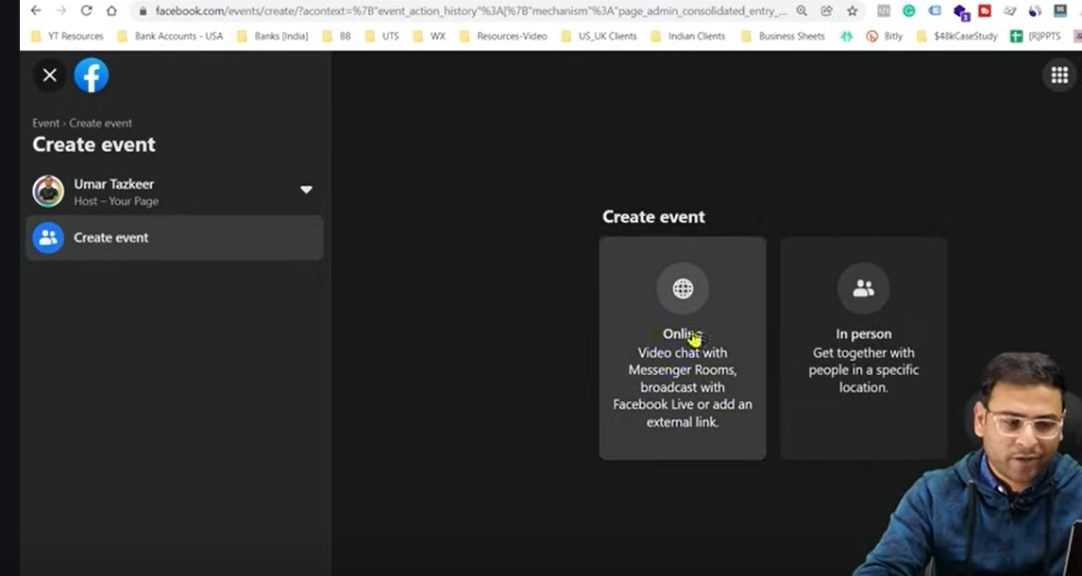

We can create online event or an offline event of public gathering

Now by clicking on offline button

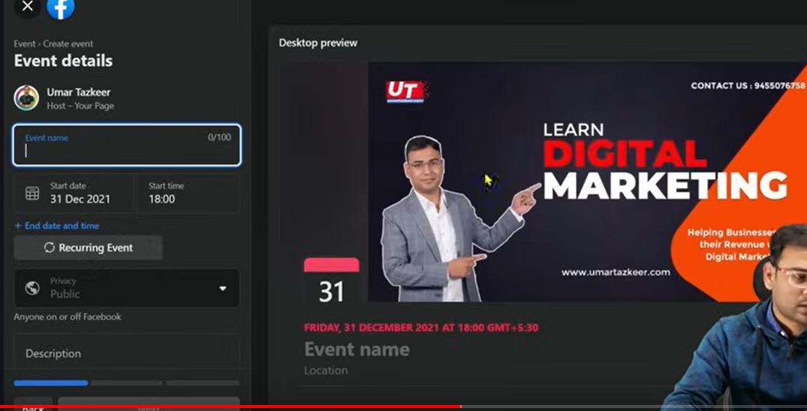you will see the interface like above

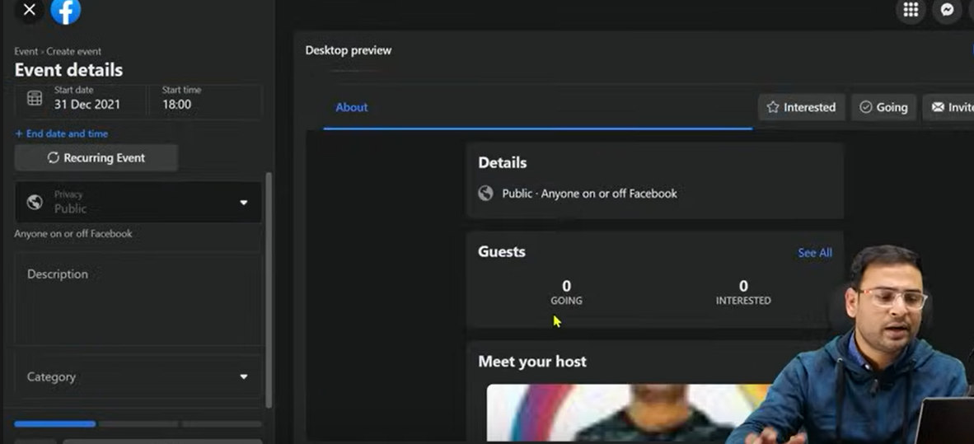You will see that when this event will happen you can see all the details above who is going or who is interested

So by this way you create event here

So many people will interact with it then how you will create custom audience on basis of it.

So if you have created any event in past

We assume that if we want to do dm workshop then for that workshop the event that was created lets asy 500 people interacted with it but only 50 people came but we can make the custom audience of rest 450 or can make a lookalike audience or we can remarket them or we can use there lookalike in different campaign because these people were those who were in our event but they did not come

So by this we have different scope through which we can create our custom audience

Now if we want to on the basis of event responses create a custom audience then we have to come to Facebook ads Manager

Now in our typical custom audience creation window we will choose events this time as shown below

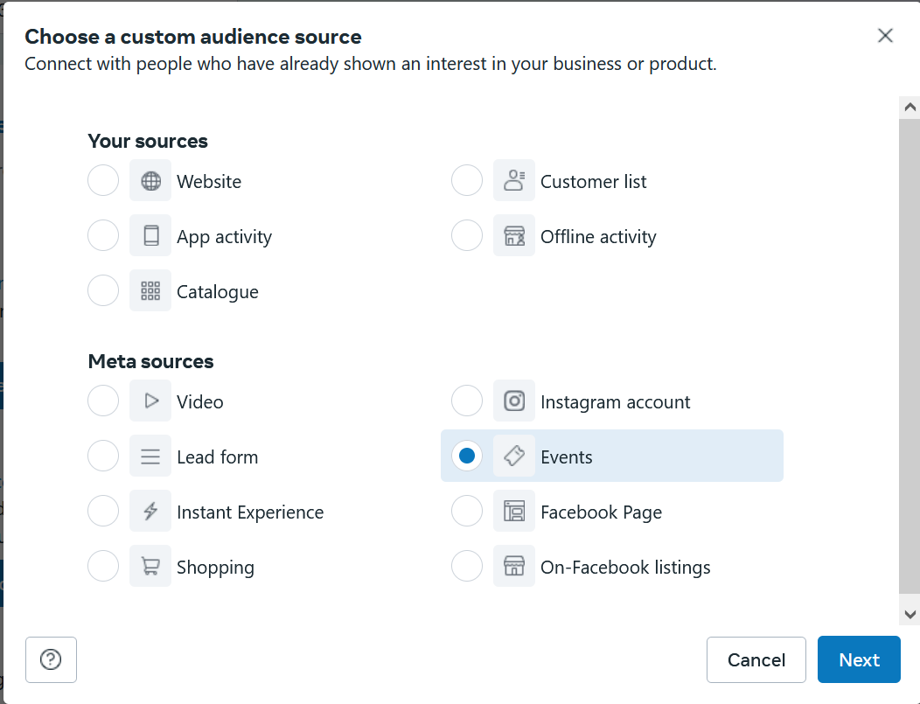

Now click on Next

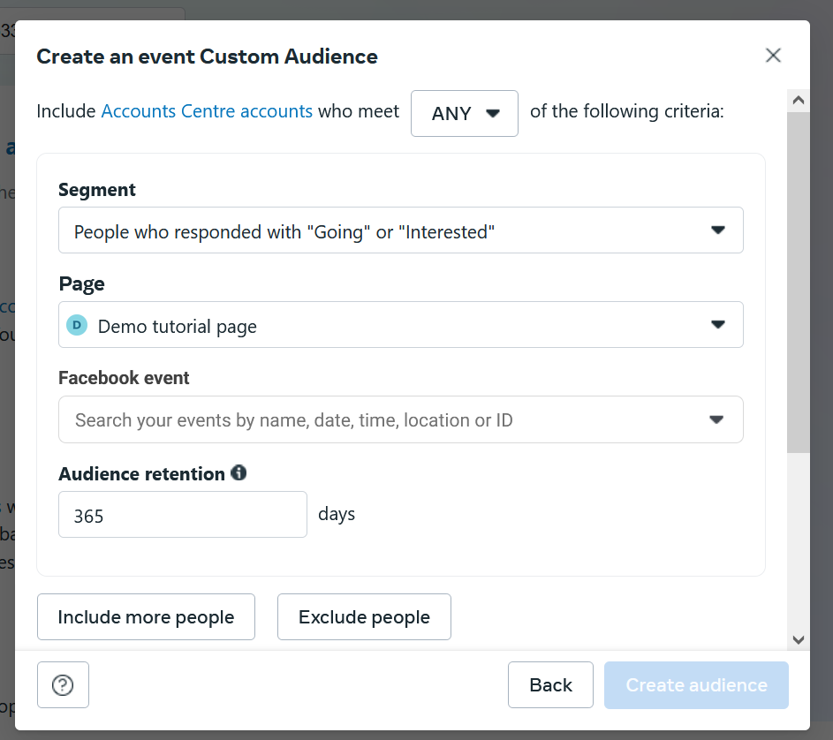

Now a new window will be shown above

In page you will choose the page in which there exist an event

And in Facebook event there will be list shown to us of events present in the Facebook Facebook page

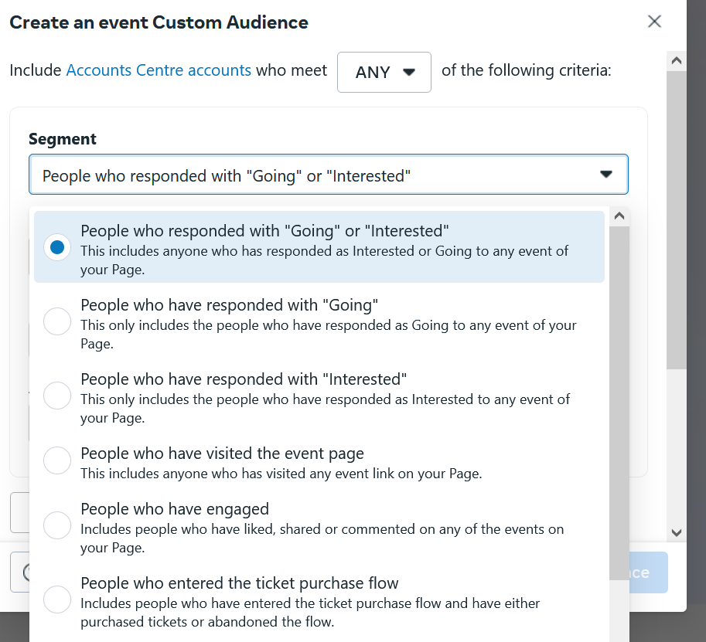

And now in segment field you get the option to create audience on the basis of responses we get

If there is event which is ticket based then weare given option that we can show our tickets there then many people purchase those tickets so many people buy this ticket if some enter in ticket purchase then on he basis of that we can create custom audience

We can make audeience on the basis of people who purchased the ticket or people who abandoned the ticket purchase measn who in the mid of purchasing the ticket abandoned it.

So guys there are many things in our Facebook platform on the basis of that we can create our custom audience

We have to see how we can make audience in better way or how by different types we can make

**Lesson 47:-**

In this lesson we will learn about **Custom audience on the basis of time**

We will see another example through which we can create our custom audience

You know when we create custom audience ,now to create custom audience we need to define some condition so here we are taking the condition time spend condition

So we are creating he audience on the basis of time spend on our website

It My look simpler but there is an important thing you need to see is that

Now when you choose website in our custom audience creation window and then click on next

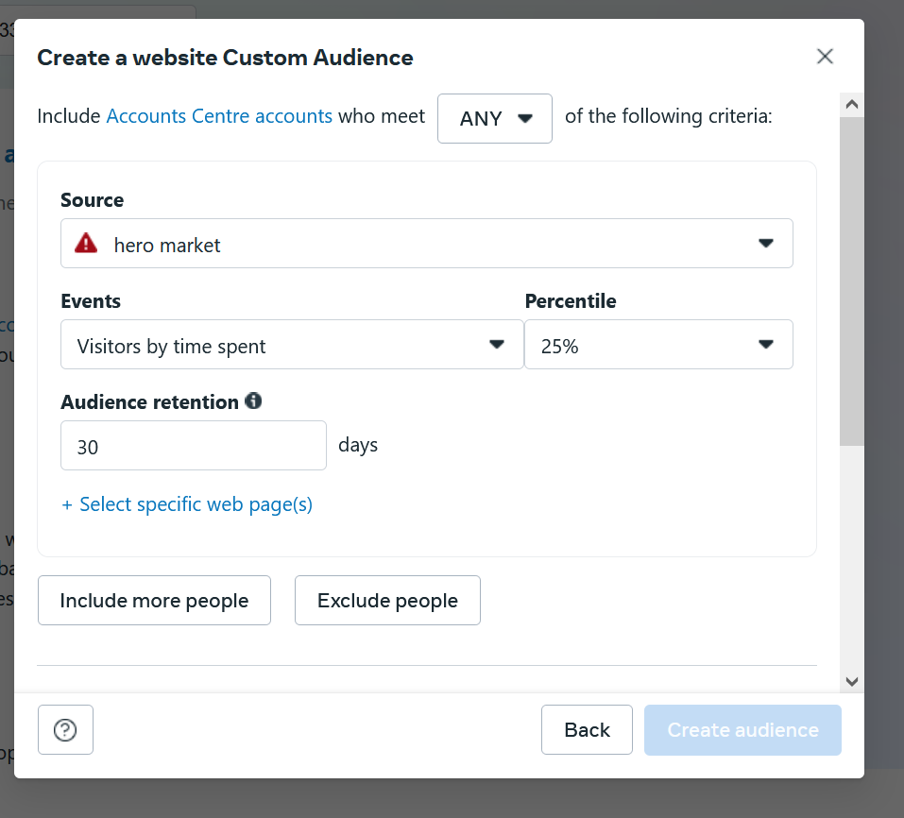

You choose the pixel in data source and then in events choose Visitor by time spent

But there is an option of percentile given beside events field

But first we need to understand the difference between Percentage and Percentile

Now suppose a person come in our website and spend 5 minutes there which was highest possible by any viewer then it will be treated as our hundred(I think it is very dynamic nature)

Now you can see in percentile 25 percentile so it means it will make audience of those people who were present in our website for 1.25 minutes or more

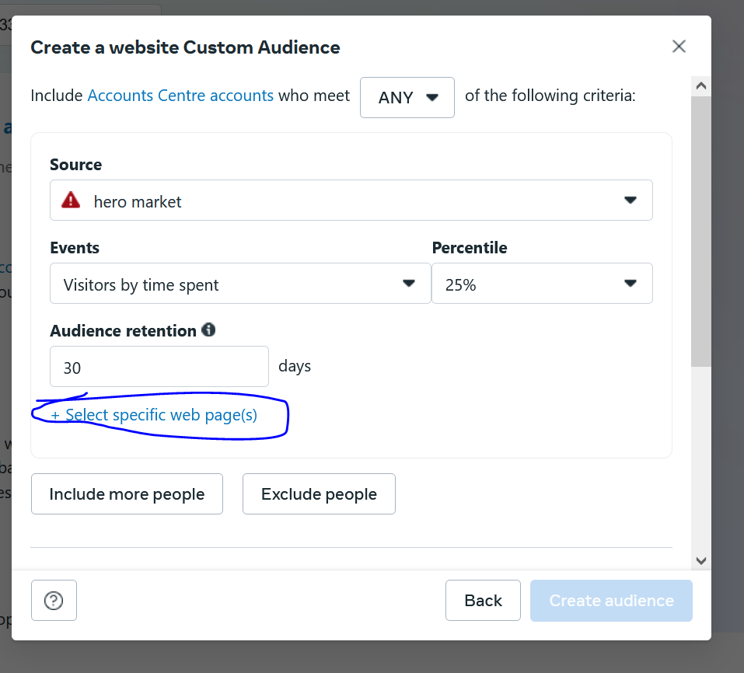

You can also make it specific by counting time spend on a webpage by clicking on marked area above and now it will like below

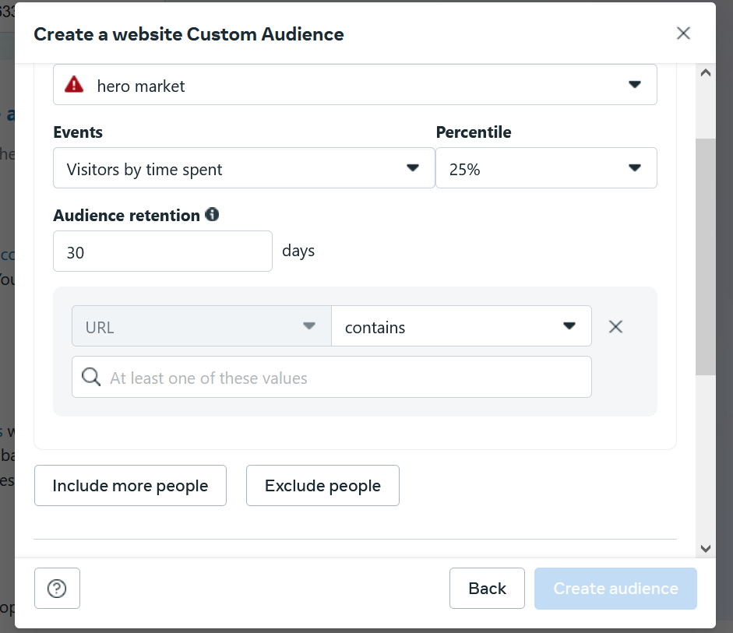

Here you tell the url of the webpage who time spend you want to be counted in the field you enter the last word you enter after the last / as it is the name of that page if the contains was selected beside the field of url.

Now set it audience and click on create audience button

**Phase 59**

**Lesson 48**

In this lesson we will learn about how to **create custom audience on the basis of visitors**

The important thing in creation is condition on what base audience is made of

Teacher has set some condition for our relief

That is

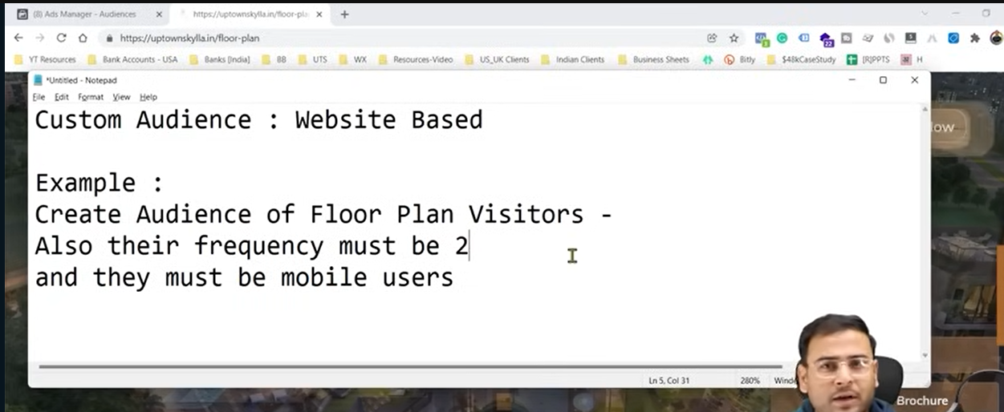

The condition is that our audinec will be the one who visit a particular page twice and they must be mobile users

With that condition how can we make our custom audience

So we will again go to our typical custom audience creation window and choose website then click on next button

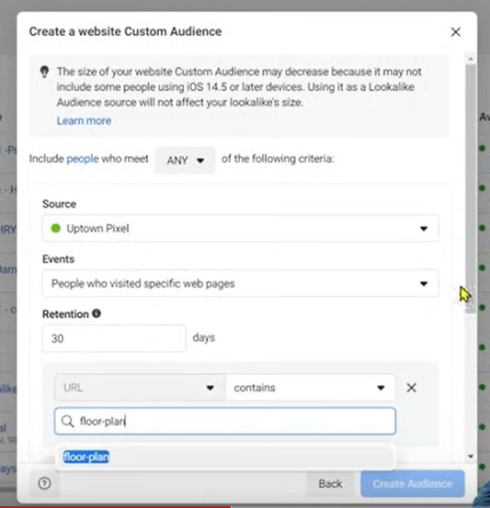

Now in our new window screen as usual there is a pixel chosen in source

And then in event we choose people who visited specific web pages and then tell the name the url can conatins

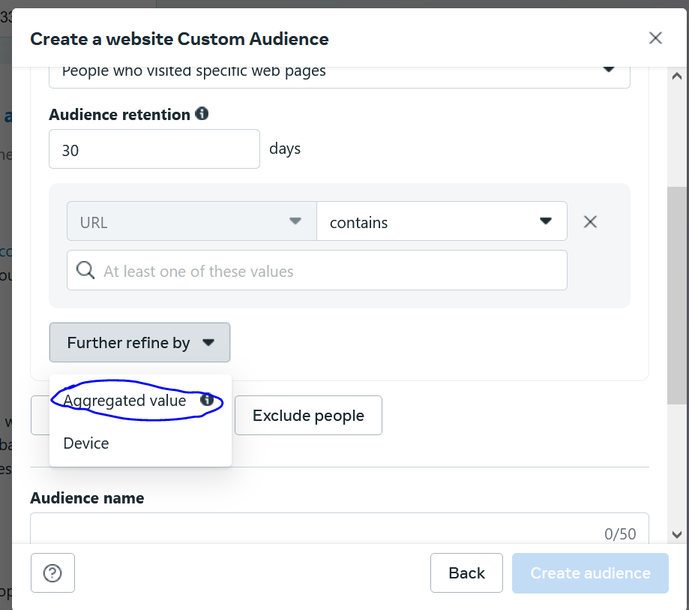

And then go to further refine by button and then a submenu will be opened .In this choose Aggregated value

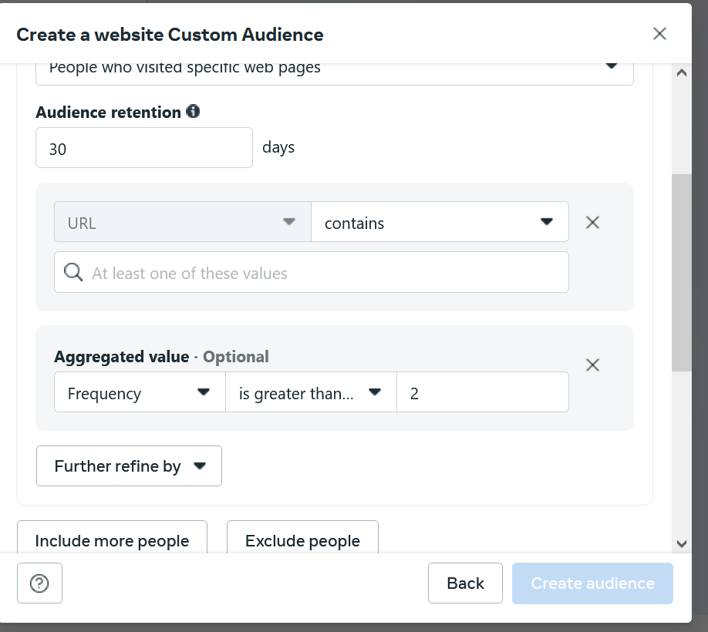

Now it will look like below

You Can see in first field Frequwncy is chosen

You can set here your frequency and then in second will tell that when ther sould be grater than or equal to or small as shown in submenu below

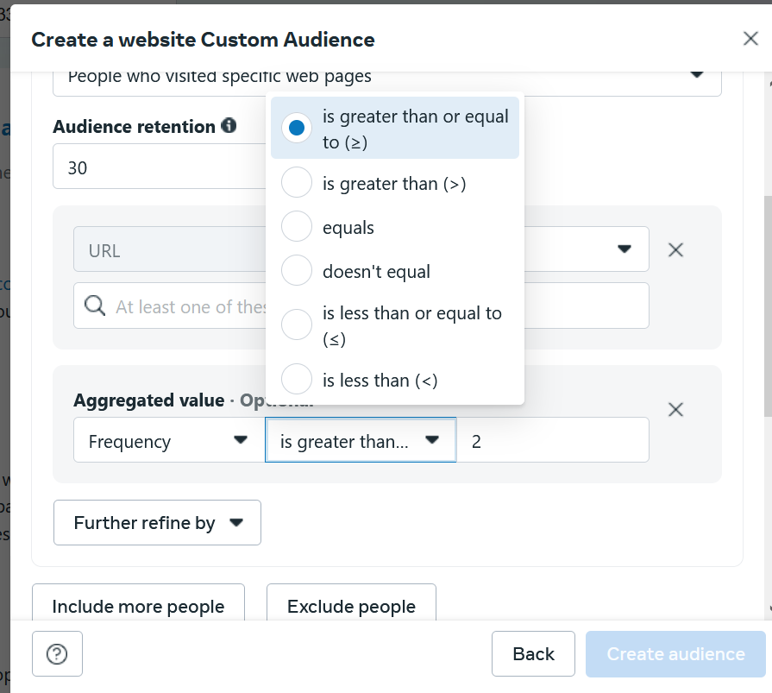

And then in third field tell the number of the frequency you want to target

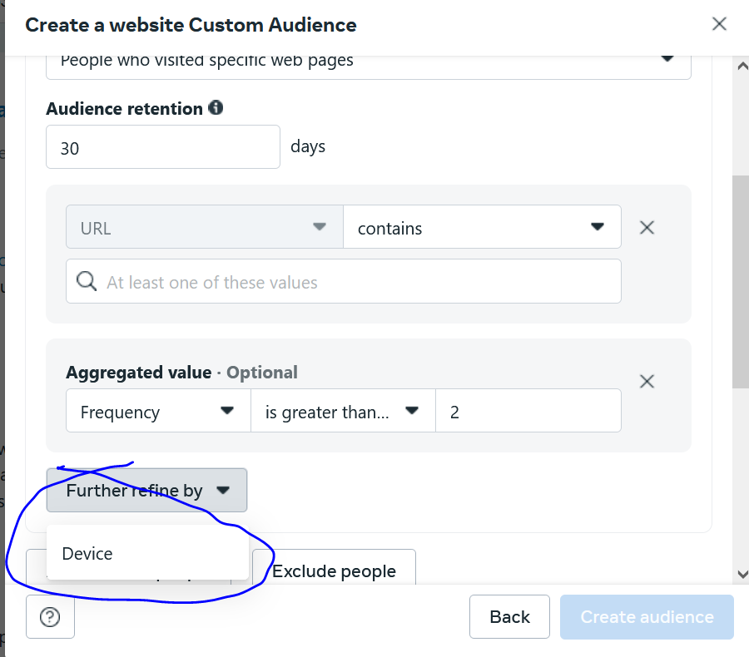

Now again click on Further refine by

And then a submenu will be opened and then chose Device in it and now it will look like below

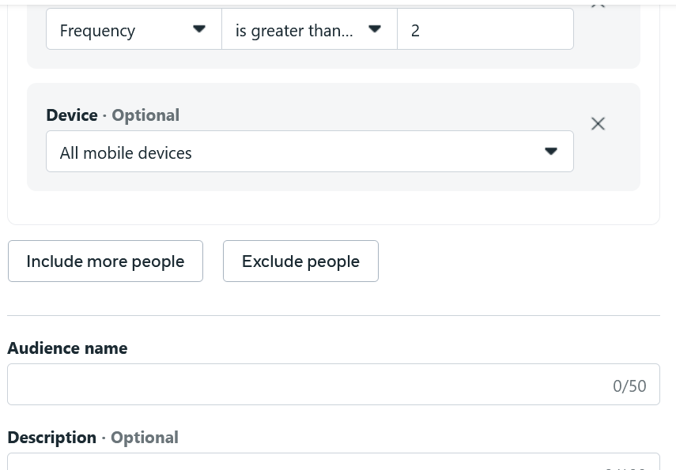

And we have chosen all Mobile devices

Teacher is giving those examples so that you learn how in different scenerios you can learn to make custom audience

Because we have limitation I saved audience

Once you make saved audience then on what interaction basis you make audience It depends

It will improve your thinking ability and analytical ability by creating different different cases itself then you will learn a lot

**Lesson 49:-**

In this lesson we will learn about the **Problem of audience of Overlapping**

What does I actually mean

And how it can be dangerous for our Facebook ad campaign

Mean we need it to avoid it

What are the things to keep in mind and how to check that our audience are overlapping or not

This lesson is important conceptwise

First we will see a case to know what it actually means and then we will see its boon or bane

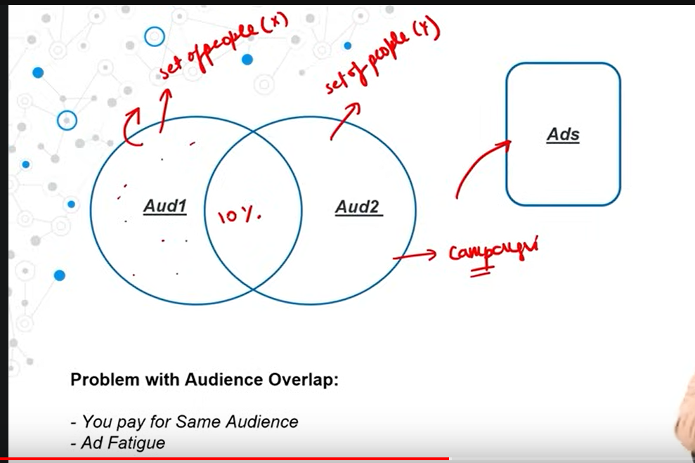

Now suppose there are audience 1 as shown above

And then audience 2 as shown above

And you can see above ther are 10 percent people coming in audience 1 and there are people common in both audience1 and audience2.

That is called the condition of overlapping

Now you will say what is the problem in this

But guys if you use these audience in a campaign but there are two different adset inside campaign one for Audience 2 and one for audience 1

Then the ads will be shown to this ten percent udiecne repeatedly

Because when we target audience 1 then it still come under it and when we target audience 2 then it still come under it so they are targeted twice So there is a problem here that is

The same creative is being shown to same people that creates an ad fatigue so what happens when an ad is shown to particular people repeatedly then the positive interaction on it get decreased

Now suppose a user see it once , twice ,thrice then the message will go to algorithm that the ad is not relevant then all the quality metrics related to ad they will be affected and then your ad will not perform and when the ad will not perform then the ad set will also not perform and overall campaign will be decreased

So the first reason is ad fatigue

Now since these audoience are common in both adset then you are also wasting money here

So now we understand that audience overlapping problem is a thing

Now if we want to check that whether audiecn overlapping happening or not and how much it is happening actually so that we can take some decision and we set the campaign in such a way that audience overlapping get reduced

So for this there is a tool in Facebook to check whether the overlapping is happening or not

So for that teacher came to Audience section and then

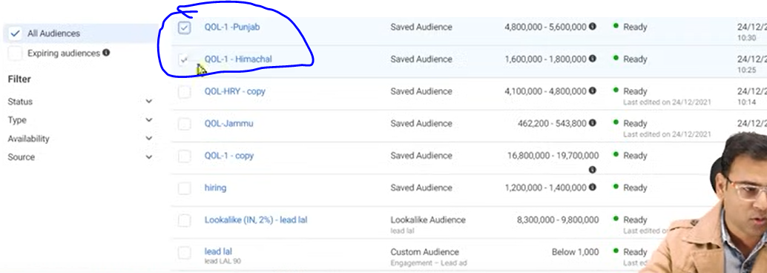

In the audience list we chose two custom audience

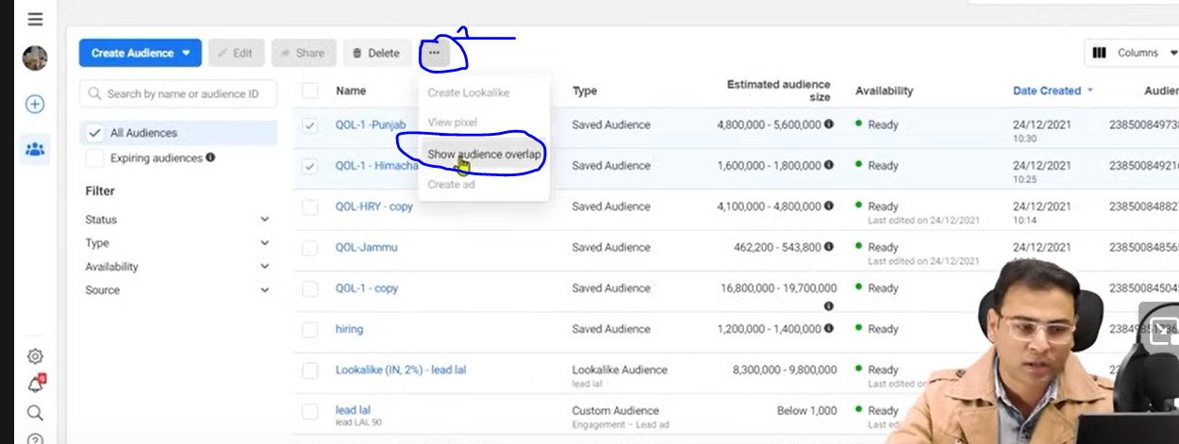

An then go to the marked 1 button a submenu appears then go to show audience overlap option

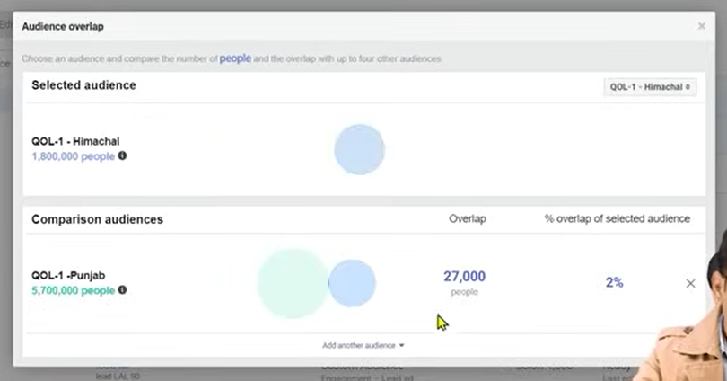

Now you can see is there overlap or not

Yes there is overlap but this overlop is just only 27000 people which is actually approx. 2 percent so it is not fatal

What if this overlap was 60 percent or 70 percent

Then you can say that in both the audience there are same type of people

So ecen we ignore any of the audience then still we can cover lots of people

**Note:-**

You can know the attributes or properties of audience by hovering over it in the list

We can take both of the audience because there is overlap it can happen that you are saying same ad to same people due to which the frequency increases and then the ad fatigue condition comes and your amount I s spend in a way that it is being shown to same people

To avoid it we need to make sure that our audience overlap does not happen and if it happens then it should be minimum so that such problem does not occur in front of us

This is the reason that your ad stop performing and ad fatigue comes so make sure initially are you not targeting an audience where situation of ad fatigue can happen or audience gets overlapped.

**Phase 60**

**Lesson 50:-**

In this lesson we will learn about **What are offline events in Facebook ads**

Now we will see about offline event setup

AS we know event is used for tracking but whatever we have studied are offline events

Now what is this offline events. What is the difference between online events and offline events

Why do we need offline events To understand it we need to understand it that until now whatever Facebook ad we were running how the ways we are running it

We are running it for the people who has online website but there can be business which can exist offline who does not have any website of their own or in their case conversion or event s are happening offline

It can happen If we take an example of consultancy

When we talk about offline hen there is now website but there something activity happened

We need it to define it but it happened offline. So this is offline events

So we take an example where we are running ad for the consultancy

Now suppose after seeing the ad the user contact us Now he come outside of Facebook system

He called us but he did not interacted with a website nor with pixel inside it.

But he came there because of Facebook ads.

Now he called us now there will be only two possibilities whether there will be consulatancy or not. Now we caome to conclusion that this was a good lead and we need that type of lead more then if it was done online then it was good thing we would have said that this add to cart which is activated , more like this should come to us then we did define add to cart and make conversion campaign and optimize it on the basis of this

Since it was offline that od phone call then we have challenge that the call we get is of good quality ad now we want that we get phones like this.

So we mean by this that we need to give hint to our campaign or Facebook ad system that the event happened is valuable event to us

So for that the event should go to Facebook how will it go?

Now we will see another case in which our consultancy we get 10 calls but we get convergence only in one call thenfor us it is an event but this event happened offline

Is it not important.Yes it is important

Then that event happened would not I want that to be put it in Facebook system

That it should be written like this offline event happen because of this campaign but here is no data flow

Which actually means that we get cal and here event happened and now from there how will the data do go to Facebook system

When we talk about event happening in website there it is asy pixel is like a bridge there sending data to faceboo that by this campaign this action happened in the website

Facebook says there are two events that is online events we see in websites and another os offline and for that we need to create sheet By sheet we mean excel sheet

In the form of exce sheet you need to create them

The Facebook will give you the template to make your excel sheet and create different events.

Now for example teacher show us a sheet

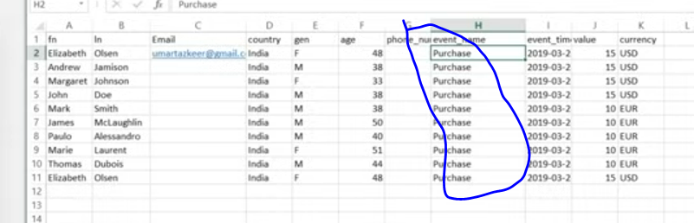

Here whatever people interacted with the teacher he as created a database here.

This database is present in the form of sheet

We can upload our data to a CRN then we can use CRN that CRN tools or CRN software , we can use them so I have to store these vents some where

Now we upload this offline events to Facebook system

Teacher will show us this step practically in future

Now we need to send this event to Facebook

Now according to template we are giving to events according ot that we tell that this is purchase event this is lead event pr add to cart event and ou will mention it in your sheet In a separate column as marked above

Now we will upload it to our Facebook system

Now you can optimize your campaign on the basis of this offline events

You can set up this campaign tracking. By tracking whatever events happened here because of it how many of them are there

You will wonder how will there be tracking setuped

In our sheet template whatever we are mentioning like phone number ,first name , last name

Now we can target the profile related to thid phone number mentioned in your database

As it has interacted with the ad so this event will get linked with campaign

There should be a database to save our events data that could be CRM or through APIs or Excel sheet which is very easy according to teacher

So first of all we need to tell that what is offline event for us.

Like offline event for is purchase

Now we will upload this data

When we did define our offline event then tracking in camoagins become easy

Campaign will tell that this phone number or email id clicked on the ad and they did this convergence measn there was role of ad in the convergence

So by this particular campaign this online event happened

The purpose of online events and offline events are same but setup of offline events is different

Now we will see it how to do it practically

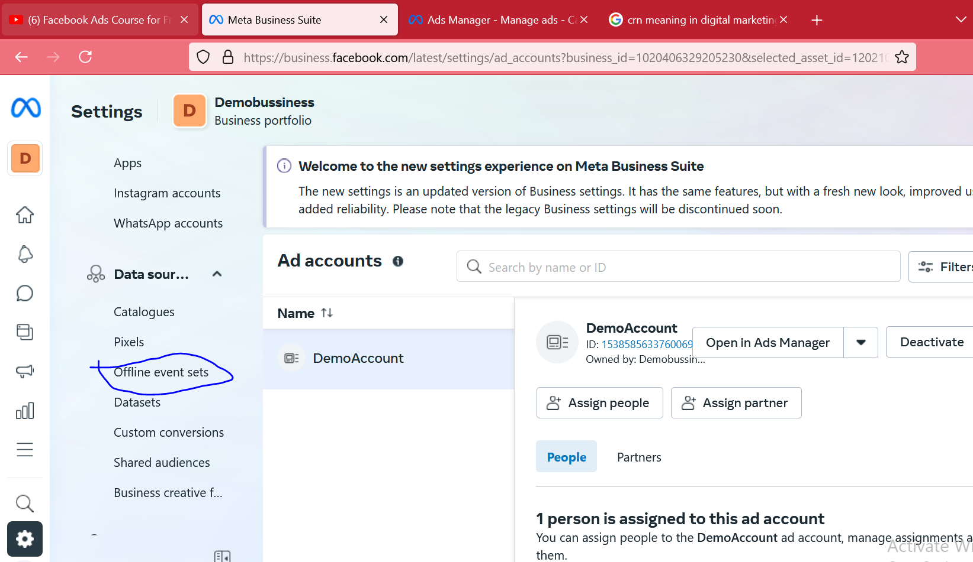

So we go to offline event sets in Bussiness Portfolio settings as marked above.

**Phase 61**

You can do so even in event manager when you click on connect data sources as below

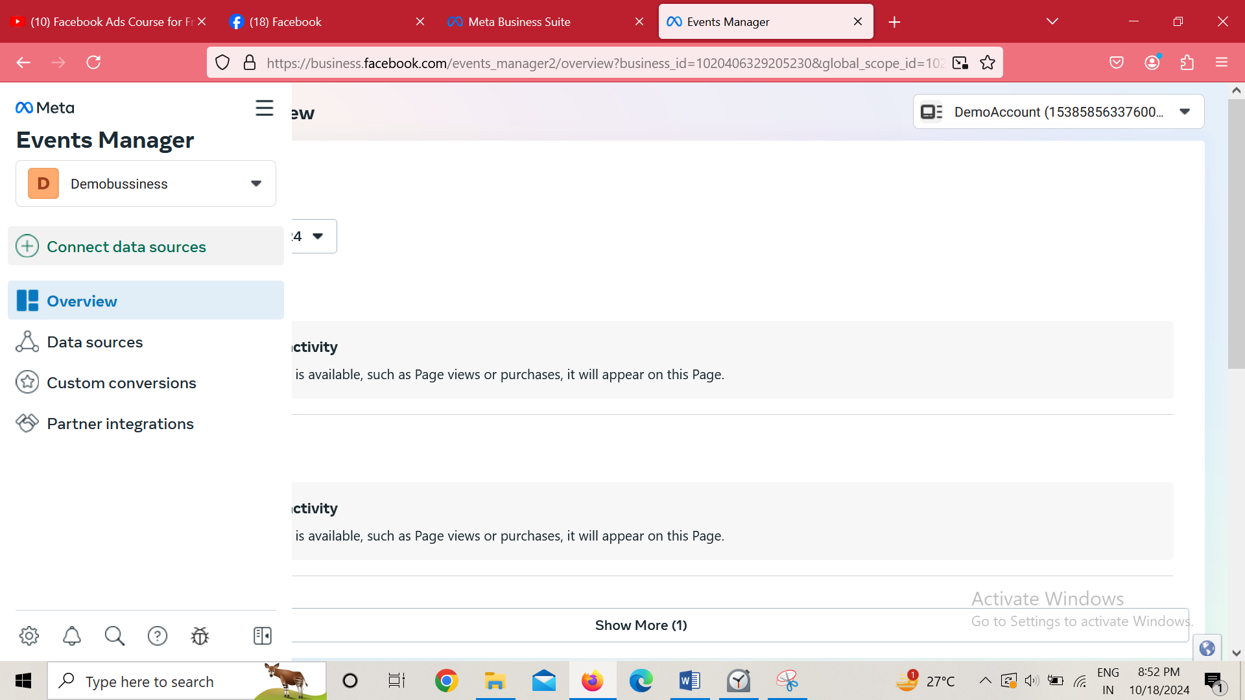

Then thwindow opens as we have studied

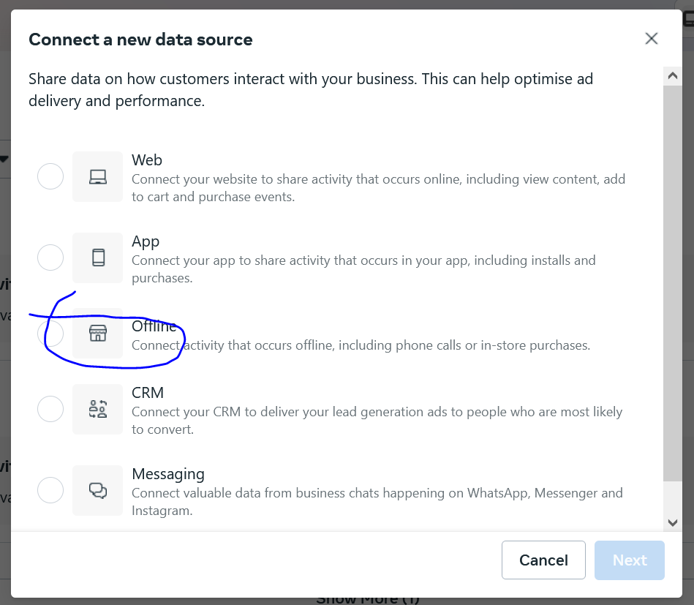you check the offline

Now when we click on next

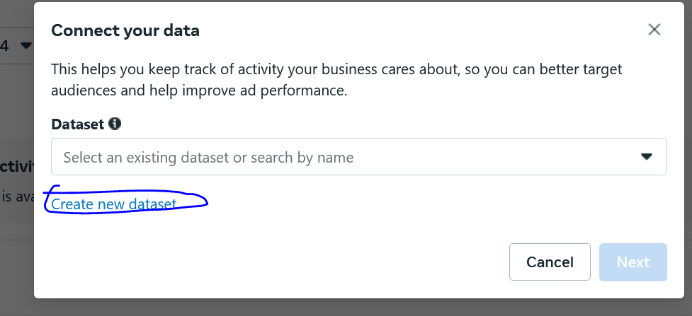

Click on create new datasets then

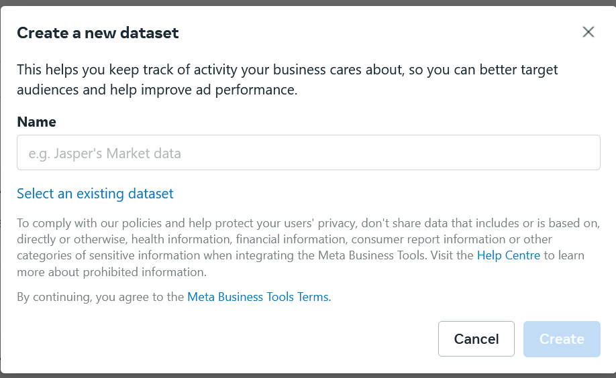

Now in name we name our offline data source(maybe event who knows)

We will see from Teacher perspective

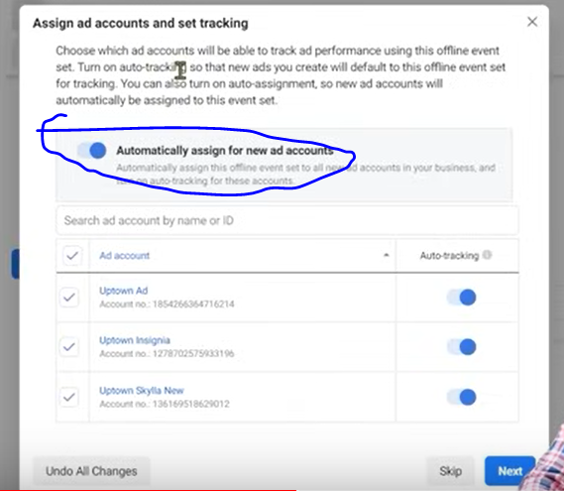

Now you want to assign this event(data source) to which account

If you check the above marked area then the whenever new ad account will be added then it will be present in it

Or you se the below that there is a list of add accounts chooseany of which you want to give

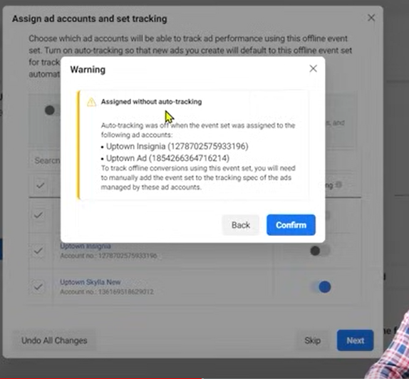

Now you will get this prompt

We click on confirm to start without tracking

So click on confirm button

Now again a mini window open click on OK in it.

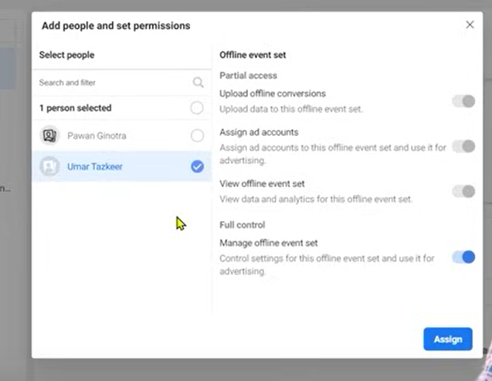

Now in above it tells that who to give access to it present in the business manager

Now click on assign button

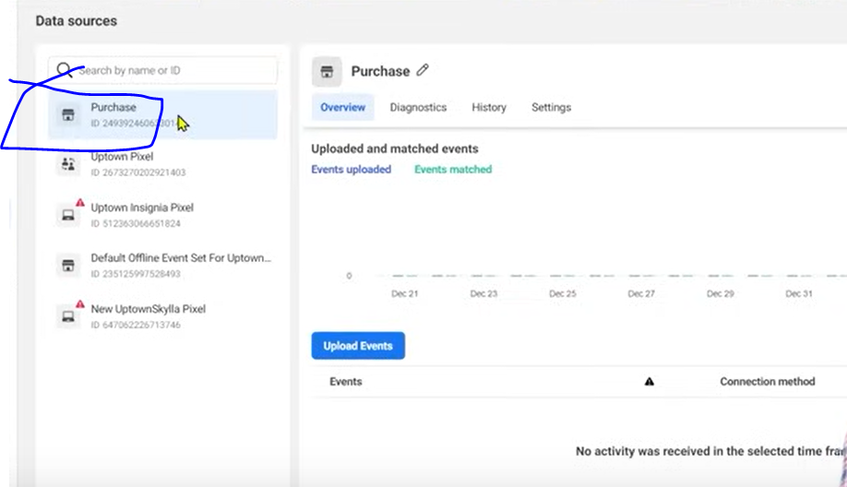

Now in above marked area you can see tnow our offline event is present in the list of events

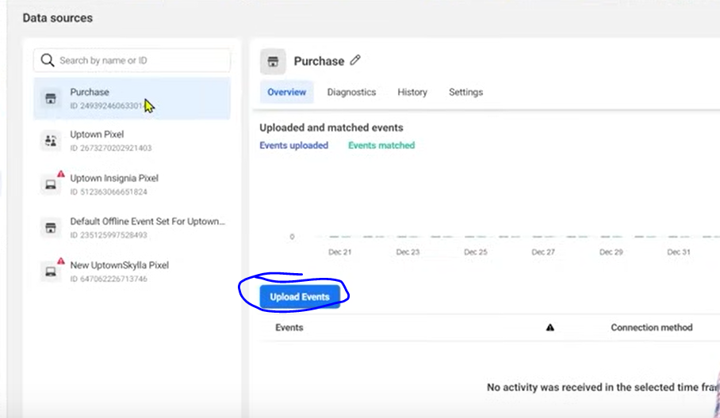

Now click on above marked area to define the evnts by uploading data to it

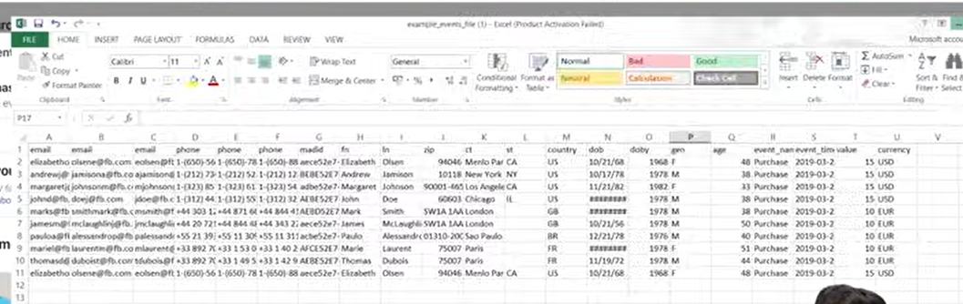

The above is sample file

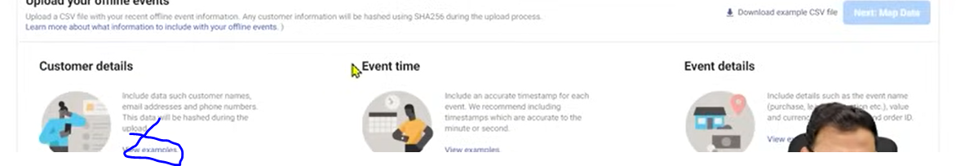

In above it is asying that your file should contain Customer details, Event time, Event details.These all you have to mention in your uploaded file

Click on view examples as marked above to there respected example like below

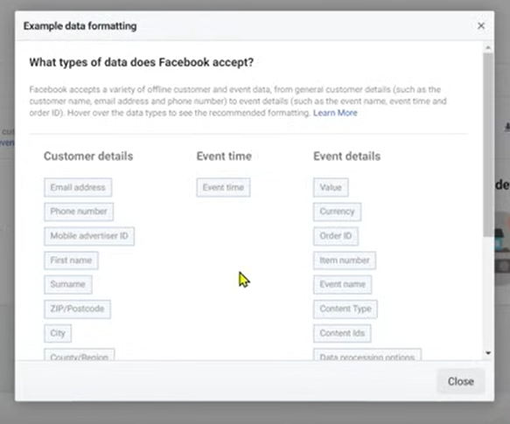

You have to repeat them yourself

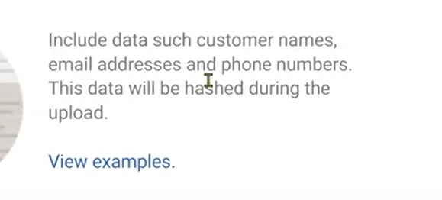

In above it is written that it will hash the data uploaded

Meaning all the data mentioned in the file will be mapped ot the the people interacted with the ad or people present in the facebook

It will check whether details mentioned in it has a profile in facebook and they interacted with any such type of ad related to this event(who knowa)

Always remember the more data you push to the system the more better it will behave

The more it will be better for campaign running that’s why the teacher says to wait for the campaign to warm up and ad account to warm up

When these system are based on AI and machine learning then how will they work without them

When you upload it then system will start mapping

Then it will ask you what are the headers

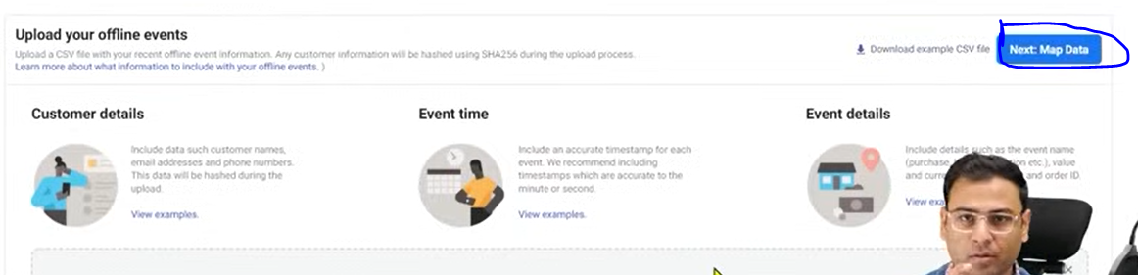

Click on next Map data as marked above 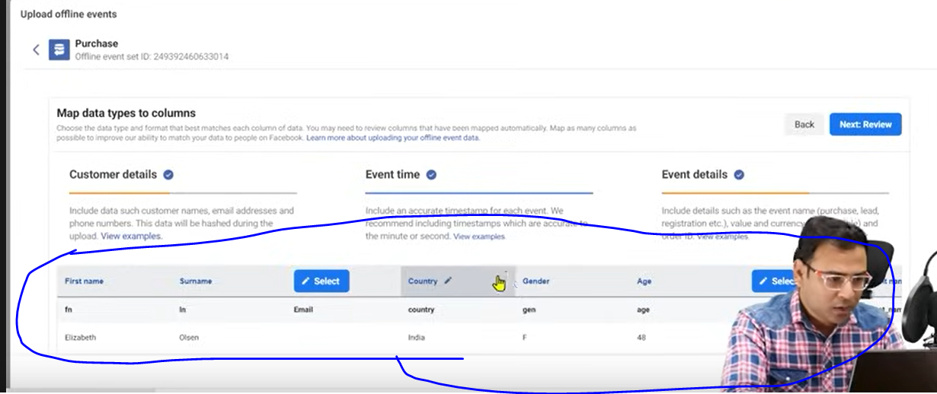

Now you willsee something like marked above

This is the data for preview which you will upload

You can ignore aome column where there is select button click on it a submenu will be opened then click on ignore

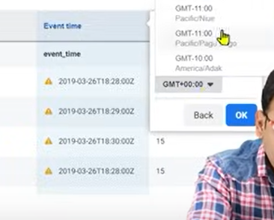

It may show error like above

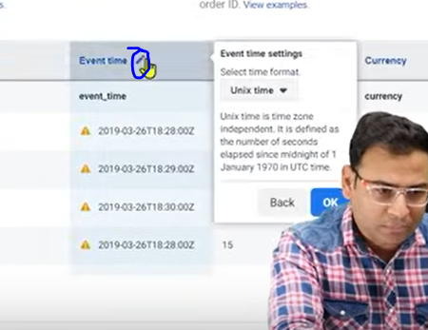

Now click on marked area to set it format

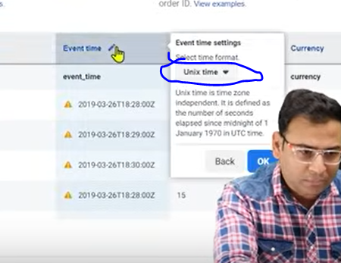

Now click on above to choose the formst here like mm-dd-yyyy

This type of error may arise dut to formatting in your sheet

Format It accorfing to facebook standard

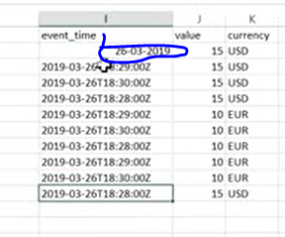

As marked above

Now click on next

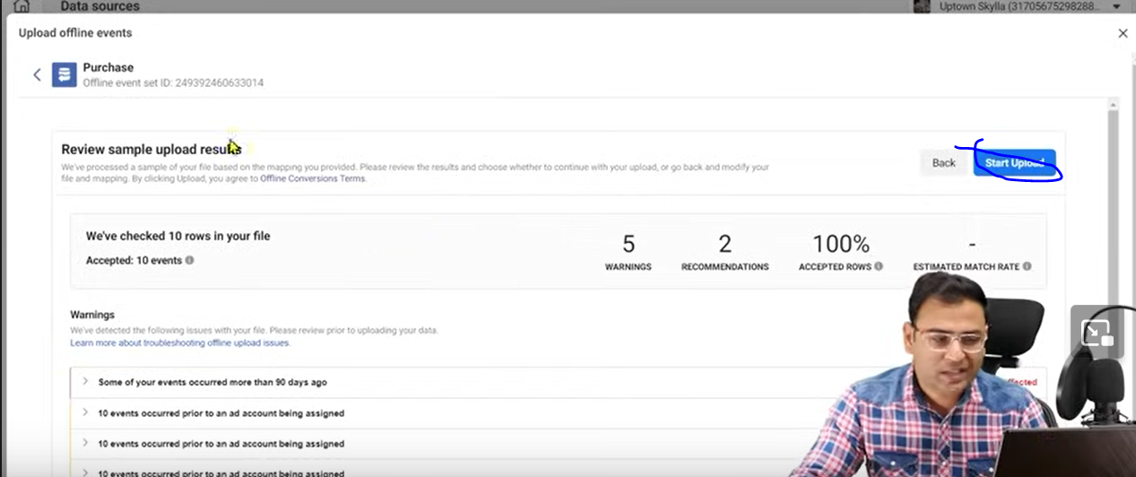

Ans htne it will look like below

You can see it is giving some warning that

The event time should be recent

Correct those error and then click on start upload as marked above

Now your data is uploaded

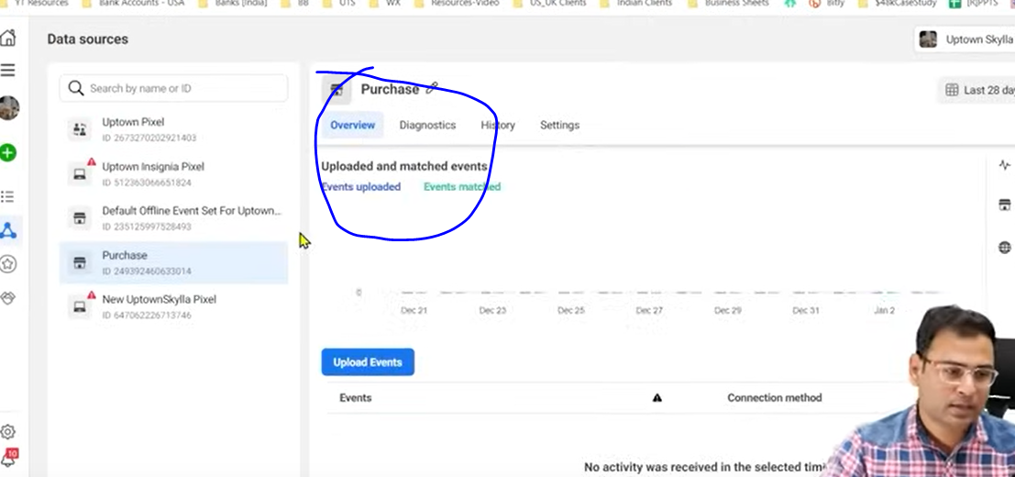

Once your mapping will be successful you are going to see the result in marked above

Now we go to ad account and create a campaign here and then go to ad level and then reach to tracking section

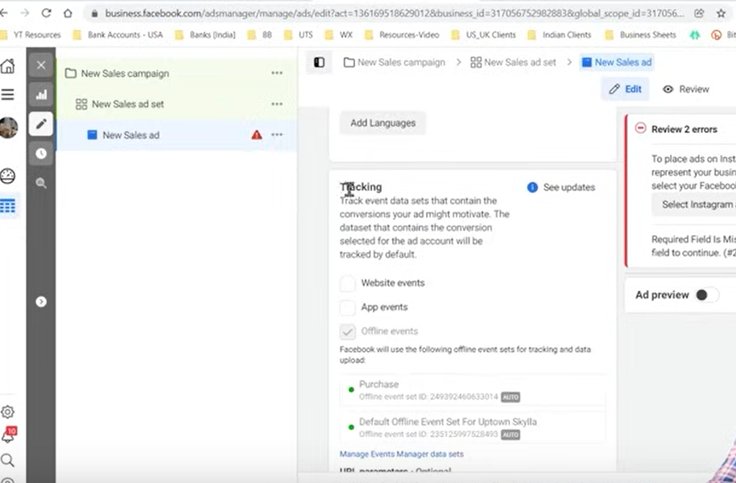

Now when you check offline events and then below this

A message will be written which actually means

When someone interact with this ad and he is present in the particular offline data then this will be used for tha particular purpose

**Lesson 51:-**

In this lesson we will learn about how to **Reduce the page like Cost in Page**

Suppose if we have a page and we want to increase its likes so can we do this by paid campaign

Does our facebook ad system give some option like this thorugh which we can achieve paid like

We will see many tricks here

There is always a concern of hoe to increase page likes

The popularity of these type of campaign has reduced

Because peo[;e have become smart and they are not taking paid page likes

Bu still some people need it

Sometimes people want to show off

Or sometimes people want when someone come to their page then there should be some numbers like how many this page like has

Some people have purpose that only number should be shown

Some have more purpose than this

Previously there was not awareness that through paid campaigns we can increase page likes

So in starting many people used this technique so they can have good social reputation So he get some brand promotion

Now people are aware and they check whether the likes on your page are genuine or not

Now suppose you do it

Then people check the profile of those people who liked you page

**Phase 62**

And from there they get the idea whether the people who like are genuine or not

It is very easy to set up such campaign

But the discussion we do before it it is important

So the purpose of such thing is that

1. Only the numbers

It does not matter for the client from wherever the likes are coming there sould be likes on this page. Such type of like you can bring in very cheap rate but by this campaign you could not achieve anything because they are just numbers and the benefit you get from number you will get it.

1. For Brand Awareness and the 3rd point are almost same

In both of them we want that people who are liking this page when I post in his page then It should reach them. Now we suppose ten thousand people like our post

And you know that the facebook organic reach is very less which we will discuss later to know why there is less organic reach in facebook When you post something there is no guarantee that to how many people will the post reach even the people who like your page and the pot reach them to all it is also not possible This is the purose that people talk about to increase in likes

1. For the purpose of making content reach to People.
2. Increasing the number page like because we can further create audience from there.(marketing style)

Because we know that on the basis of interaction and page likes we can increase our custom audience If we can make custom audience then we can make lookalike audience So what we are understanding there on the basis of people who like our page we can make our audience .Lookalike audience will be good when its source will be good.

When the custom audience quality is not good then the lookalike audience quality will not be good. So this is a problem So purpose is that if I have large likes then we can rate a custom audience If you want good quality people who like the page then in that particular case your audience targeting in a very good way .That means you want like from relevant people . This is the purpose of only for the numbers. Now the problem comes when you do a very specific targeting like the people should be in a particular profession or from a particular city then in that particular case your page like cost is more means

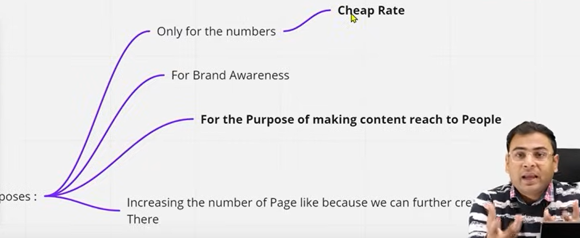

First we try to unserstand the purpose of page likes and then we understand that there are purpose 2,3 ,4 are important not the first according to teacher but if you want then you can but there is no concern of cost that we are getting page like expensive or cheap because the main focus is not running page like campaign but to run it efficiently then for that we need to understand

So we understand that if we want relevant audience in the form of page likers then we have to select some specific audience but the problem with specific audience is that they are expensive the more we narrow the expensive cost per result get. It happens in every campaign whether itis lead campaign or traffic campaign in traffic campagin cost per result is link click. Or there can be cost on landing page. Iin lead form if we go narrow then that form cost will more

Now you will say we want to decrease it what are the ways thoruhg which we decrease our cost

Now there are some good ways and there are some jugaadu ways. And whatever thing is right you can follow it

For decreasing audience we have two ways either we play with audience or with creative and keep these things in mind

The like ad look like below

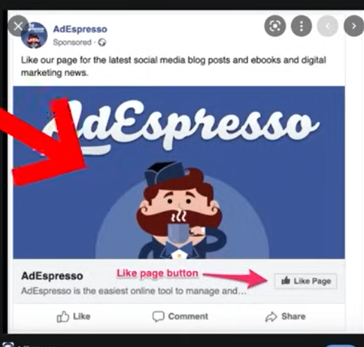

There will be an image and there will be text above it it should not be big we don’t write big text in like campaign ads.

We are not doing awareness here we are doing here an action but the main point is that you see here is that you see like button here here stratigtward we have option to like our page

Here we have call to action to like our page the person who is viewing our ad if he get influenves by our ad copy then he will like this page then the reole of creative is very big

Suppose we have targeted very ggod audience but if our creative is not in right and not compelling that the person will like it.so creative has a very big role to play here.

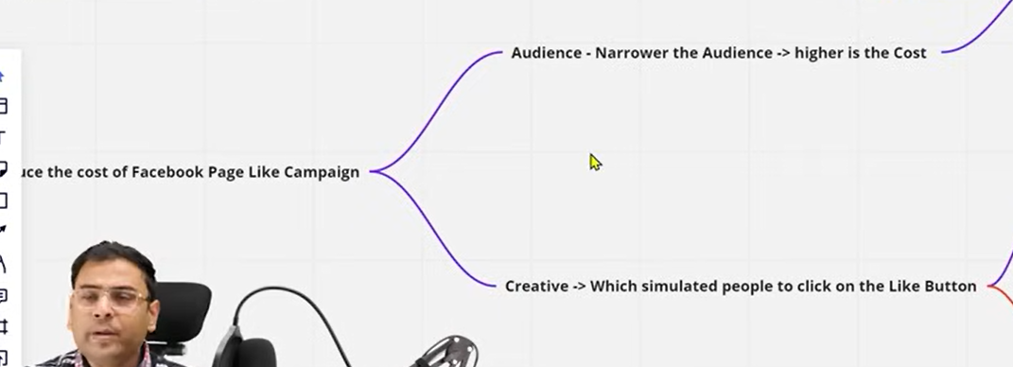

So there are two major concern

AS we know narrowing the audience higher is the cost So you have to make sure your audience is wide

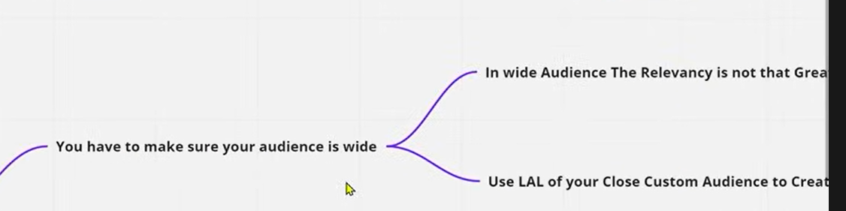

How to make it wide and even if we wide it then there is problem that relevancy will hamper

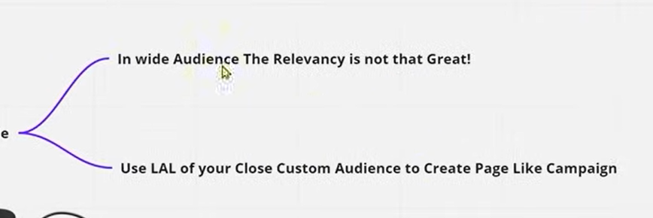

So to solve it use Lookalike audience of your close custom audience to create pge like campaign

It means the page like campaign you will create you have to add audience in it then we are not sayin g to your saved or cold audience in wide way interest based teacher is saying that the people who already like your page make there your custom audience or who visited you website make there custom audience now when you ake there look alike audience so the people who visited your website there characteristics is clear that they are interested in your website type or interested in your business x now if we create lookalike audiecn then they are by default wide and then we make lookalike audience of 1 percent 2 percent or 3 percent we create lookalike audience(who knows)

So lookalike audience check this that the audience we formed is wide

So now if we use lookalike audience in our page like campaign then our critereia get fulfilled like our audience becomes wide and slightly relevant. And we can make different different ad groups and test different lookalike audience.

Second way the people use is by playing with creatives

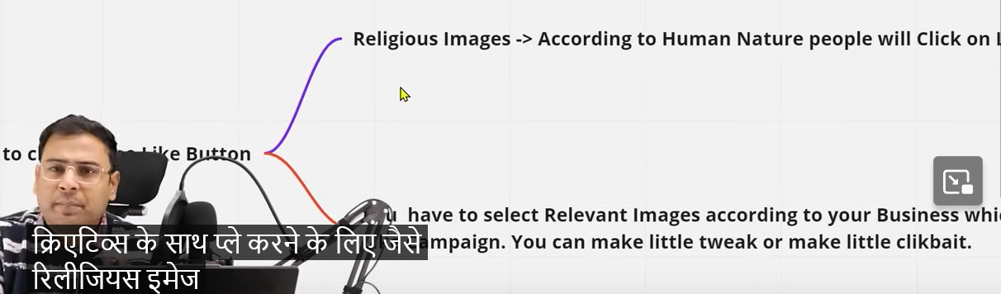

Like we put religious picture here tehn It will trigger emotions then the person will become emotional and will not see the content and like this Many marketers use this technique. You can use it if you want but it is not recommended by the teacher because the person may have like the page but on the bais of the religious influence you make the page liked but he even don’t knoe anything about page and the page like is increasing and